Lab Sheet: 2

Objective:
To understand and implement SQL transactions using COMMIT, SAVEPOINT, and ROLLBACK, retrieve records using SELECT queries, and perform INSERT, UPDATE, and ALTER operations on tables.
Instructions:
- Open your preferred Database Management System (DBMS) tool.
- Create the required tables: CLASS, EMPLOYEES, and Client_master.
- Insert the given/suitable records into each table.
- Execute the SQL scripts and queries step by step.
- Observe the output carefully after each operation, especially after ROLLBACK and UPDATE commands.

DDL Questions (Data Definition Language):
1. How do you create a table named CLASS with appropriate data types?
CREATE TABLE CLASS (
D INT PRIMARY KEY,
Name VARCHAR(50) NOT NULL
);
2. How do you create a table named EMPLOYEES with the specified attributes?
CREATE TABLE EMPLOYEES (
Employee_Id INT PRIMARY KEY,
First_Name VARCHAR(50),
Last_Name VARCHAR(50) NOT NULL,
Email VARCHAR(100) UNIQUE,
Phone_Number VARCHAR(20),
Hire_Date DATE NOT NULL,
Job_Id VARCHAR(20),
Salary DECIMAL(10, 2),
Commission_Pct DECIMAL(4, 2),
Manager_Id INT,
Department_Id INT
);
3. How do you create a table named Client_master with the specified attributes?
CREATE TABLE Client_master (
Client_no VARCHAR(6) PRIMARY KEY,
Name VARCHAR(20) NOT NULL,
Address1 VARCHAR(30),
City VARCHAR(15),
Pincode INT,
State VARCHAR(15),
bal_due DECIMAL(10, 2)
);
4. What SQL statement would you use to rename the table Client_master to Client12?
ALTER TABLE Client_master
RENAME TO Client12;
5. How do you display the bal_due column heading as “BALANCE”?
SELECT bal_due AS BALANCE
FROM Client12;

DML Questions (Data Manipulation Language):
Part A: Transactions and Savepoints (CLASS Table)
Give the output of the following SQL script:
  - INSERT INTO class VALUES (5,’Rahul’);
  - COMMIT;
  - UPDATE class SET name = ‘Abhijeet’ WHERE id=’5’;
  - SAVEPOINT A;
  - INSERT INTO class VALUES (6,’Chris’);
  - SAVEPOINT B;
  - INSERT INTO class VALUES (7,’Bravo’);
  - SAVEPOINT C;
  - SELECT * FROM class;
  - ROLLBACK TO B;
  - SELECT * FROM class;
  - ROLLBACK TO A;
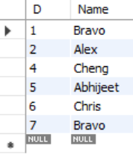
Part B: Retrieving Records (EMPLOYEES Table)
1. Find out the employee id, names, and salaries of all the employees.
SELECT Employee_Id, First_Name, Last_Name, Salary
FROM EMPLOYEES;
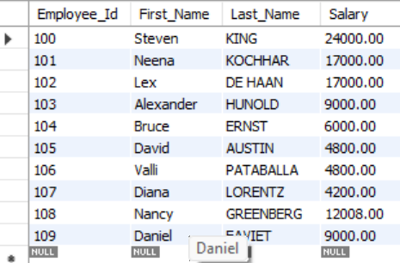
2. List out the employees who work under manager 100.
SELECT * FROM EMPLOYEES
WHERE Manager_Id = 100;
3, Find the names of the employees who have a salary greater than or equal to 4800.
SELECT First_Name, Last_Name
FROM EMPLOYEES
WHERE Salary >= 4800;
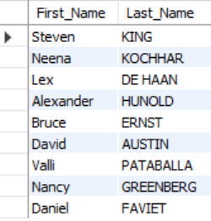
4. List out the employees whose last name is ‘AUSTIN’.
SELECT * FROM EMPLOYEES
WHERE Last_Name = 'AUSTIN';
5. Find the names of the employees who work in departments 60, 70, and 80
SELECT First_Name, Last_Name
FROM EMPLOYEES
WHERE Department_Id IN (60, 70, 80);
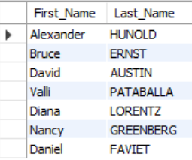
6. Display the unique Manager_Id.
SELECT DISTINCT Manager_Id
FROM EMPLOYEES;
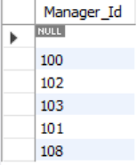
Part C: Updating Records (Client_master Table)
1. Insert five records into the Client_master table.
INTO Client12 (Client_no, Name, City, State, Pincode, bal_due)
VALUES
('C121', 'Ivan Bayross', 'Mumbai', 'Maharashtra', 400001, 15000.50),
('C122', 'Mamta Muzumdar', 'Madras', 'Tamil Nadu', 780001, 0),
('C123', 'Chhaya Bankar', 'Mumbai', 'Maharashtra', 400057, 4500.00),
('C124', 'Ashwini Joshi', 'Bangalore', 'Karnataka', 560001, 7500.25),
('C125', 'Hansel Colaco', 'Mumbai', 'Maharashtra', 400060, 2000.00);
2. Find the names of clients whose bal_due > 5000.
SELECT Name
FROM Client12
WHERE bal_due > 5000;
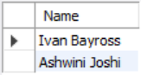
3. Change the bal_due of ClientNO "C123" to Rs. 5100.
UPDATE Client12
SET bal_due = 5100
WHERE Client_no = 'C123';

